1. Selecione nome e dataNascimento dos alunos que começam com a letra "X".

[SELECT](http://localhost/phpmyadmin/url.php?url=https://dev.mysql.com/doc/refman/5.5/en/select.html) nome, dataNascimento FROM `aluno` WHERE nome [LIKE](http://localhost/phpmyadmin/url.php?url=https://dev.mysql.com/doc/refman/5.5/en/string-comparison-functions.html#operator_like) 'k%'

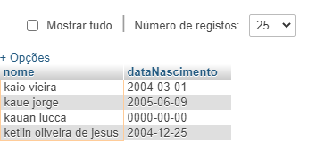

2)Selecione nome e email e dataNascimento dos alunos que nasceram no mês x;

[SELECT](http://localhost/phpmyadmin/url.php?url=https://dev.mysql.com/doc/refman/5.5/en/select.html) nome, email, dataNascimento FROM aluno WHERE month(dataNascimento) = '12'

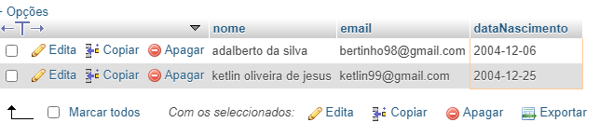

3)Selecione nome e telefone dos alunos que nasceram no ano x;

SELECT nome, email, dataNascimento FROM aluno WHERE YEAR(dataNascimento) = '2003'

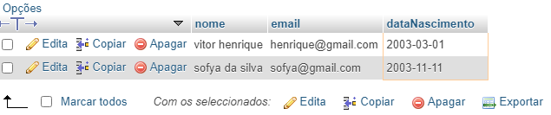

4) Ordene os alunos em ordem decrescente por Turma;

[SELECT](http://localhost/phpmyadmin/url.php?url=https://dev.mysql.com/doc/refman/5.5/en/select.html) * FROM `aluno` ORDER BY turma DESC

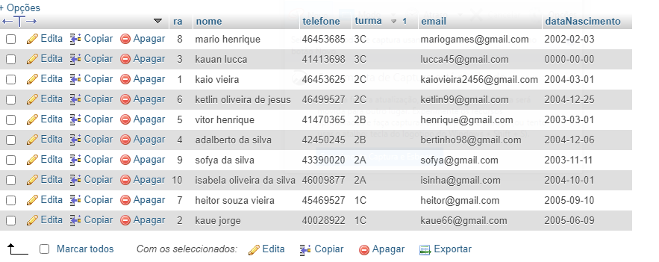

5) Selecione os livros do Gênero "X";

[SELECT](http://localhost/phpmyadmin/url.php?url=https://dev.mysql.com/doc/refman/5.5/en/select.html) titulo, autor, genero FROM livro WHERE genero [LIKE](http://localhost/phpmyadmin/url.php?url=https://dev.mysql.com/doc/refman/5.5/en/string-comparison-functions.html#operator_like) '%romance%'

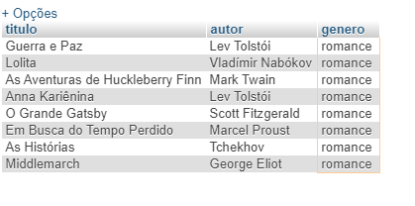

6) Quantos livros tem cadastrados;

[SELECT](http://localhost/phpmyadmin/url.php?url=https://dev.mysql.com/doc/refman/5.5/en/select.html) [COUNT](http://localhost/phpmyadmin/url.php?url=https://dev.mysql.com/doc/refman/5.5/en/group-by-functions.html#function_count)(*) FROM livro

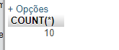

7) Selecione os livros do autor "X";

[SELECT](http://localhost/phpmyadmin/url.php?url=https://dev.mysql.com/doc/refman/5.5/en/select.html) titulo, autor, genero FROM livro WHERE autor = 'Lev Tolstói'

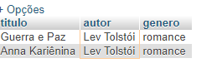

8) Selecione os empréstimos que aconteceram no mes "X";

[SELECT](http://localhost/phpmyadmin/url.php?url=https://dev.mysql.com/doc/refman/5.5/en/select.html) data_emprestimo FROM emprestimo_devolucao WHERE month(data_emprestimo) = '05'

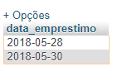

9) Selecione os empréstimos que aconteceram entre os anos "X" e "Y";

[SELECT](http://localhost/phpmyadmin/url.php?url=https://dev.mysql.com/doc/refman/5.5/en/select.html) data_emprestimo, data_devolucao, ra FROM `emprestimo_devolucao` WHERE data_emprestimo BETWEEN '2018-01-01' [AND](http://localhost/phpmyadmin/url.php?url=https://dev.mysql.com/doc/refman/5.5/en/logical-operators.html#operator_and) '2019-12-31'

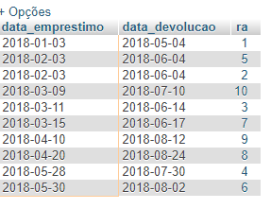

10) Selecione os bibliotecarios que são da cidade "X";

[SELECT](http://localhost/phpmyadmin/url.php?url=https://dev.mysql.com/doc/refman/5.5/en/select.html) nome, cidade FROM bibliotecario WHERE cidade = 'maua'

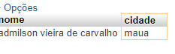

11)Ordene os bibliotecarios em ordem alfabética;

[SELECT](http://localhost/phpmyadmin/url.php?url=https://dev.mysql.com/doc/refman/5.5/en/select.html) * FROM `bibliotecario` ORDER BY nome DESC

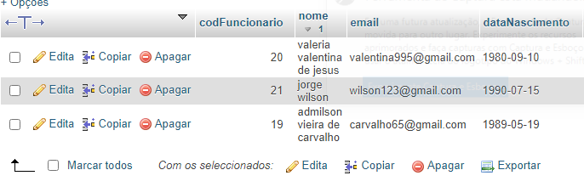

12) Ordene os livros por gênero;

[SELECT](http://localhost/phpmyadmin/url.php?url=https://dev.mysql.com/doc/refman/5.5/en/select.html) * FROM `Livro` ORDER BY genero

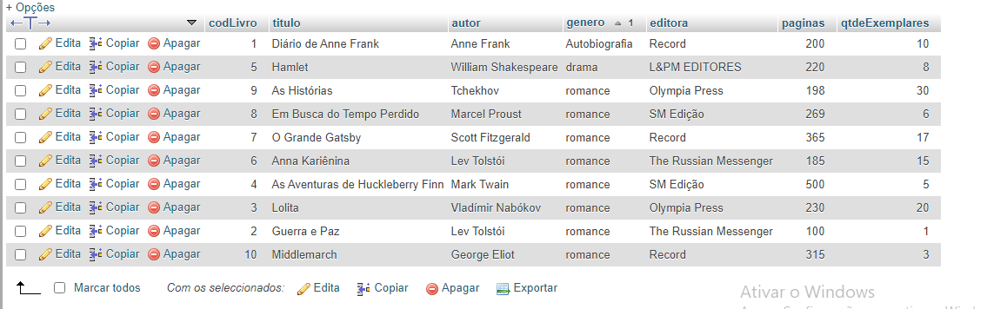

13) Selecione os livros da editora "X";

[SELECT](http://localhost/phpmyadmin/url.php?url=https://dev.mysql.com/doc/refman/5.5/en/select.html) titulo, editora FROM livro WHERE editora = 'Record'

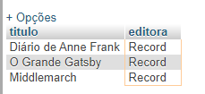

14) Selecione os livros dos autores "X" ou genero "Y" e que tenham menos de "Z" páginas;

[SELECT](http://localhost/phpmyadmin/url.php?url=https://dev.mysql.com/doc/refman/5.5/en/select.html) titulo, autor, genero, paginas FROM livro WHERE (autor= 'anne frank' [OR](http://localhost/phpmyadmin/url.php?url=https://dev.mysql.com/doc/refman/5.5/en/logical-operators.html#operator_or) genero='Romance') [AND](http://localhost/phpmyadmin/url.php?url=https://dev.mysql.com/doc/refman/5.5/en/logical-operators.html#operator_and) paginas <200

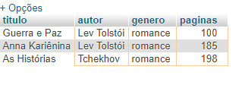

15) Selecione os livros com titulo que começam com a letra "X" e genero "X";

[SELECT](http://localhost/phpmyadmin/url.php?url=https://dev.mysql.com/doc/refman/5.5/en/select.html) titulo, genero FROM `livro` WHERE titulo [LIKE](http://localhost/phpmyadmin/url.php?url=https://dev.mysql.com/doc/refman/5.5/en/string-comparison-functions.html#operator_like) 'a%' [AND](http://localhost/phpmyadmin/url.php?url=https://dev.mysql.com/doc/refman/5.5/en/logical-operators.html#operator_and) genero = 'Romance'

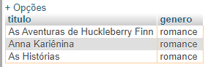

16) faça a média de paginas de todos os livros;

[SELECT](http://localhost/phpmyadmin/url.php?url=https://dev.mysql.com/doc/refman/5.5/en/select.html) [AVG](http://localhost/phpmyadmin/url.php?url=https://dev.mysql.com/doc/refman/5.5/en/group-by-functions.html#function_avg) (paginas) FROM livro

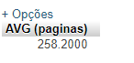

17) faça a soma de páginas de todos os livros;

[SELECT](http://localhost/phpmyadmin/url.php?url=https://dev.mysql.com/doc/refman/5.5/en/select.html) [SUM](http://localhost/phpmyadmin/url.php?url=https://dev.mysql.com/doc/refman/5.5/en/group-by-functions.html#function_sum)(paginas) FROM livro

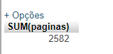

18) Selecione os livros que tenham entre 2 e 8 exemplares

[SELECT](http://localhost/phpmyadmin/url.php?url=https://dev.mysql.com/doc/refman/5.5/en/select.html) titulo, autor, genero, qtdeExemplares FROM livro WHERE qtdeExemplares BETWEEN 2 [AND](http://localhost/phpmyadmin/url.php?url=https://dev.mysql.com/doc/refman/5.5/en/logical-operators.html#operator_and) 8

